Networking task
- Get me the IP address of a particular domain (guvi.in). How do I find my CPU/memory usage of my server?. Test the connectivity between 2 nodes?

- I used Ns lookup and the dig command to get the ip address of the Guvi.in

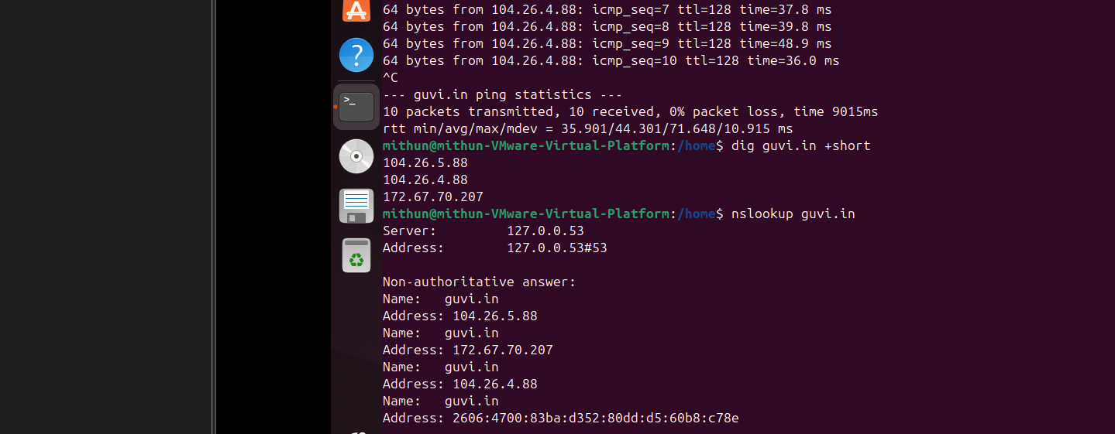
- To check the connectivity I used the ping command to check the connection.
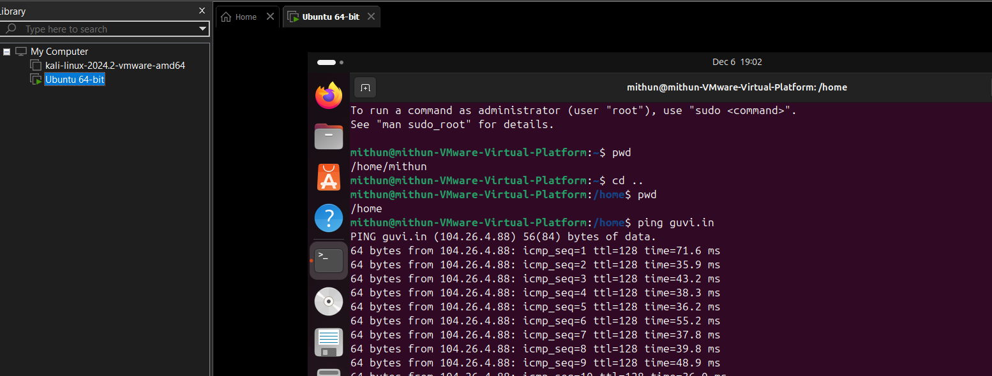
- To check the connection path I used traceroute command
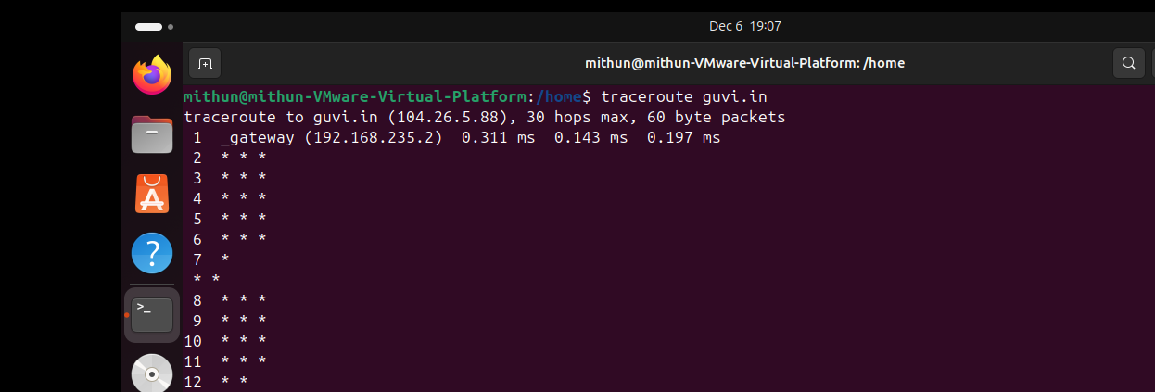
- Used top command to look after the CPU and memory of the server

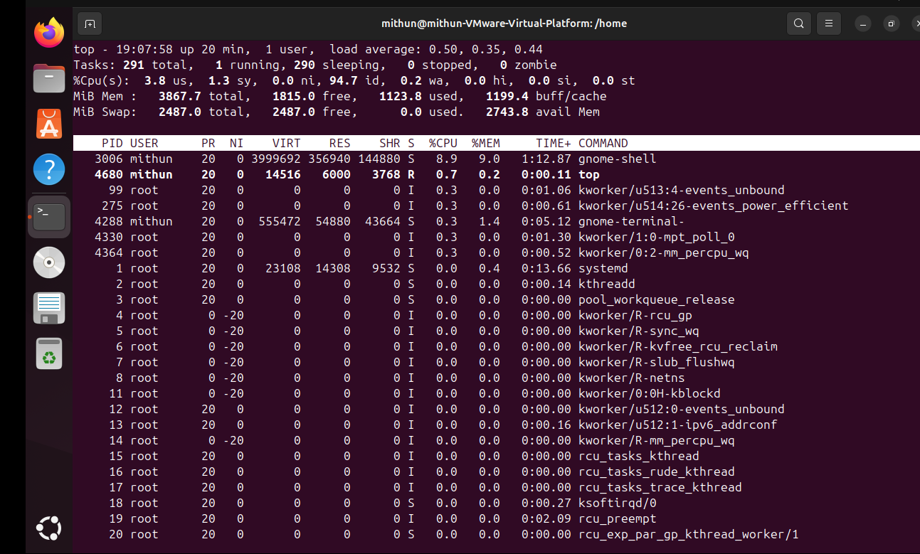
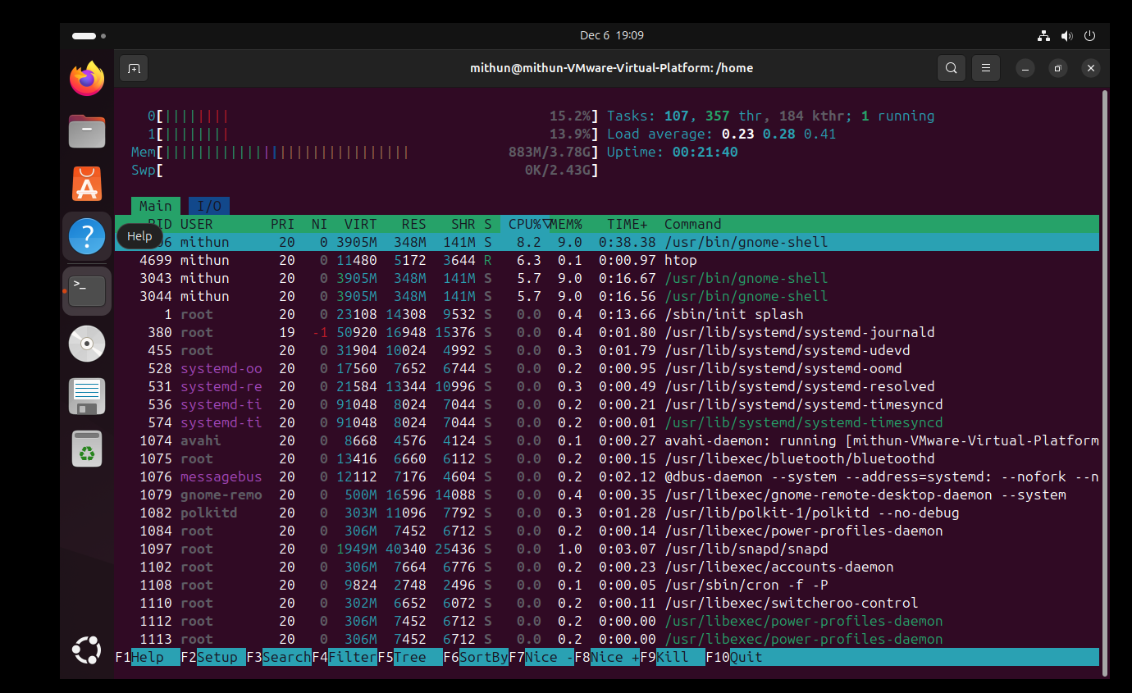
- To check the CPU usage by the files consuming used mpstat command
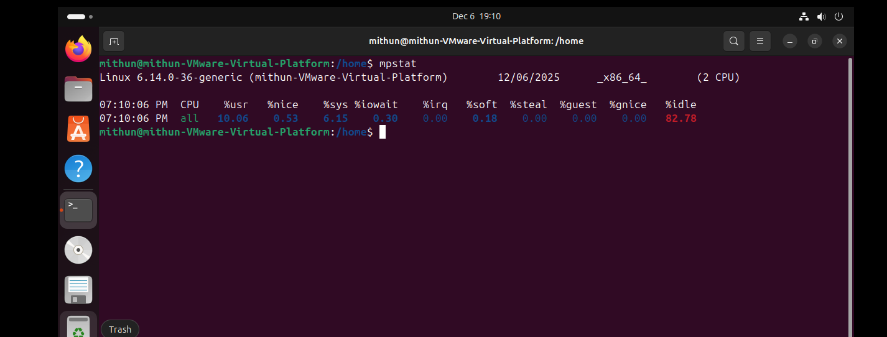
- To check the memory used free -h command
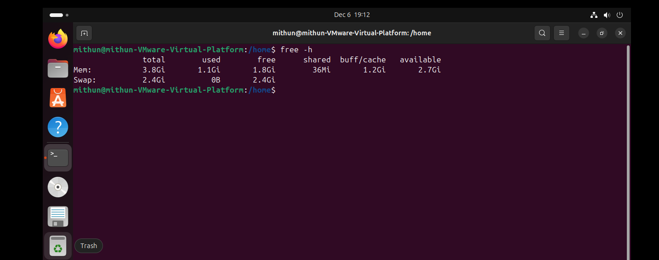
- To check the complete memory information used cat /proc/meminfo
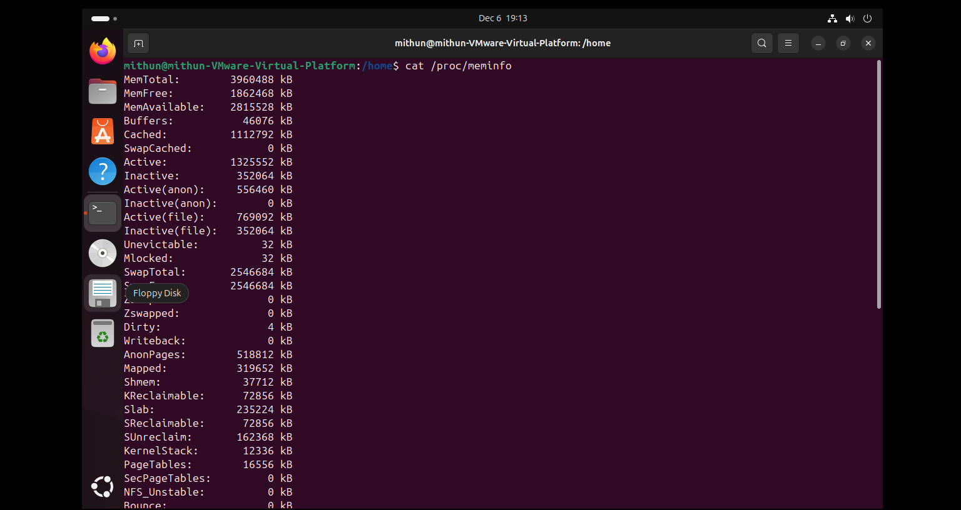
- I have deployed an application in guvi.com:9000, and logs show my app is running, but I’m unable to view the page. Check whether my port is open or not ?

- Installed the Nmap in ubuntu and verified from nmap to check the connection logs and also enable the firewall rules and permitted 9000 in the TCP

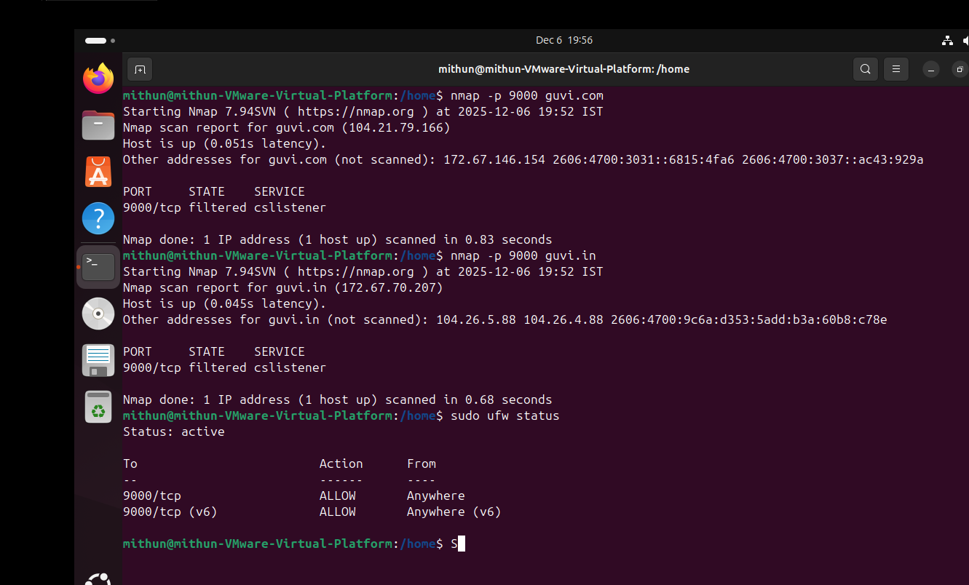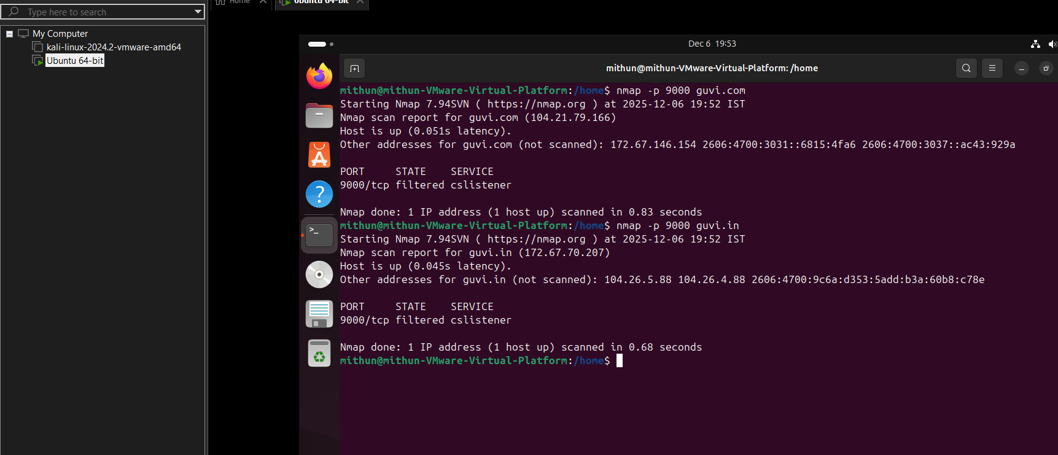
And as per the result the status shows as filtered and that is meant not accessible externally.

